SPRING CLOUD

https://spring.io/projects/spring-cloud/#overview

Micro-services Challenges and Spring Cloud Solutions.


1.

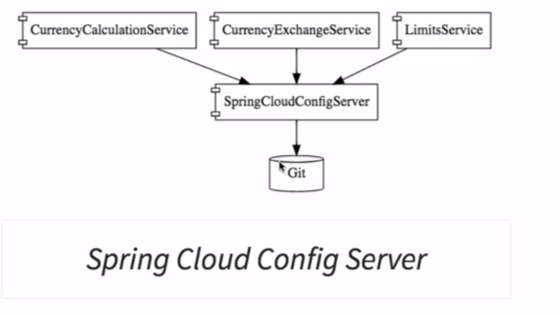

2. Dynamic Scale up and scale down: Spring cloud load balancer instead of Ribbon.

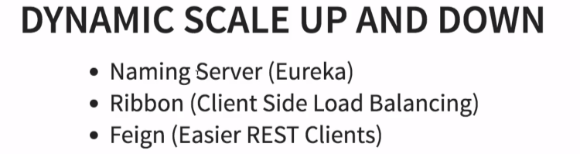

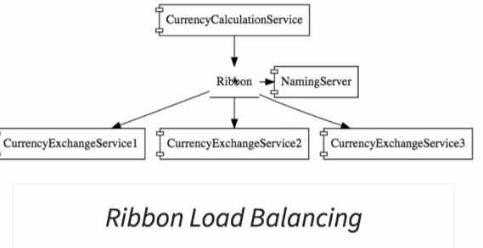

3. Visibility and Monitoring:
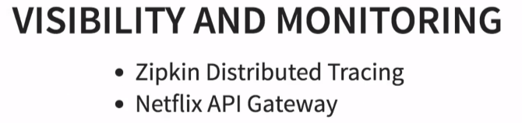

4. Fault Tolerance: Resilience4j

ADVANTAGES OF MICRO-SERVICES

1. Auto-Scaling
2. Faster release cycle
3. New technologies adaptation

